**Case Study-3**

Name: **E.R Harish**

1. **Loan Data File:**
2. **Number of loans in each category:**

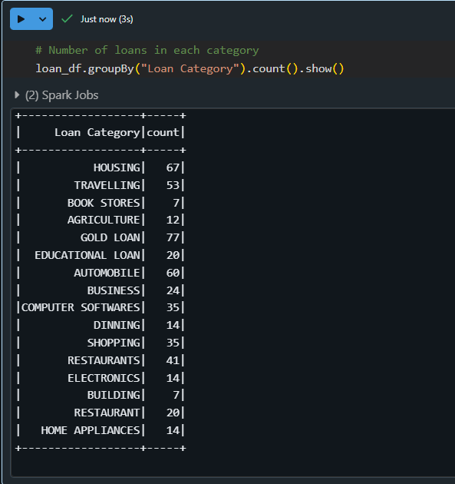

**Explanation:**

* 'groupBy' groups the data based on the 'Loan_Category' column.
* 'count' calculates the number of rows in each group.

1. **Number of people with income greater than 60000 rupees:**



**Explanation:**

* 'filter' selects rows where 'Income' > 60000.

1. **Number of people with 2 or more returned cheques and income less than 50000:**



**Explanation:**

* Use '&' for logical AND.
* Filter rows where 'Returned_Cheques' >= 2 and 'Income' < 50000.

1. **Number of people with expenditure over 50,000 a month:**



**Explanation:**

* Filter rows where 'Expenditure' > 50000.

1. **Credit File:**
2. **Credit card users in Spain:**



**Explanation:**

* Filter rows where 'Country' is "Spain".

1. **Number of members who are eligible and active in the bank:**

Assuming "eligible" is determined by a CreditScore > 650



**Explanation:**

* Filter rows where 'Eligible' and 'Active' columns have "Yes".

1. **Transactions File:**
2. **Maximum withdrawal amount:**



**Explanation:**

* Use 'agg' to calculate the maximum value in the 'Withdrawal_Amount' column.

1. **Minimum withdrawal amount of an account:**



**Explanation:**

* Similar to the above but use 'min' for the minimum value.

1. **Maximum deposit amount of an account:**

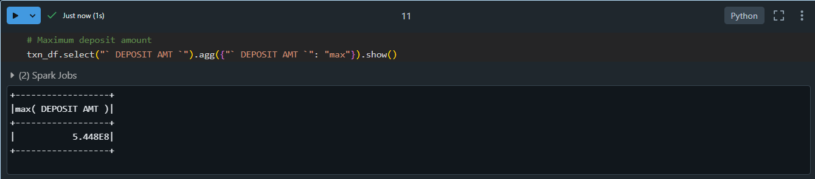

**Explanation:**

* Find the maximum value in the 'Deposit_Amount' column.

1. **Minimum deposit amount of an account:**



**Explanation:**

* Use 'min' for the minimum deposit amount.

1. **Sum of balance in every bank account:**

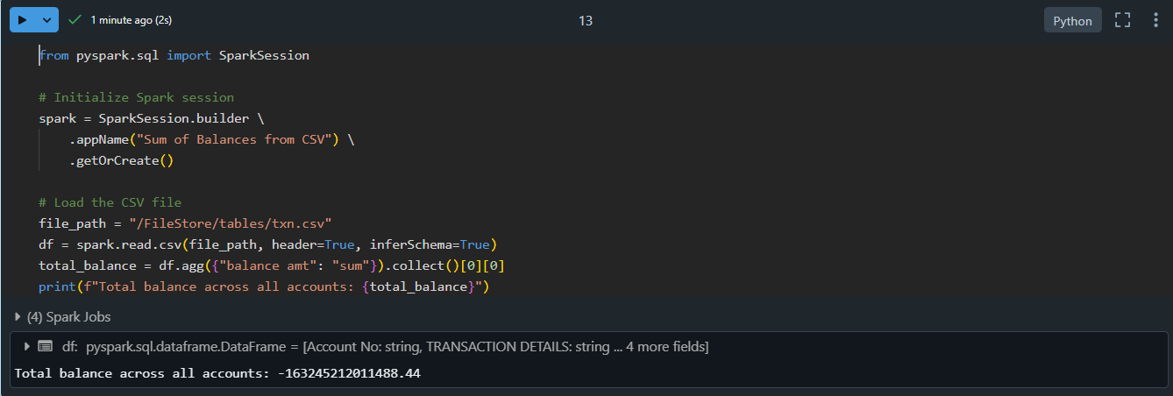

**Explanation:**

* Use 'agg' to calculate the sum of all values in the 'Balance' column.

1. **Number of transactions on each date:**

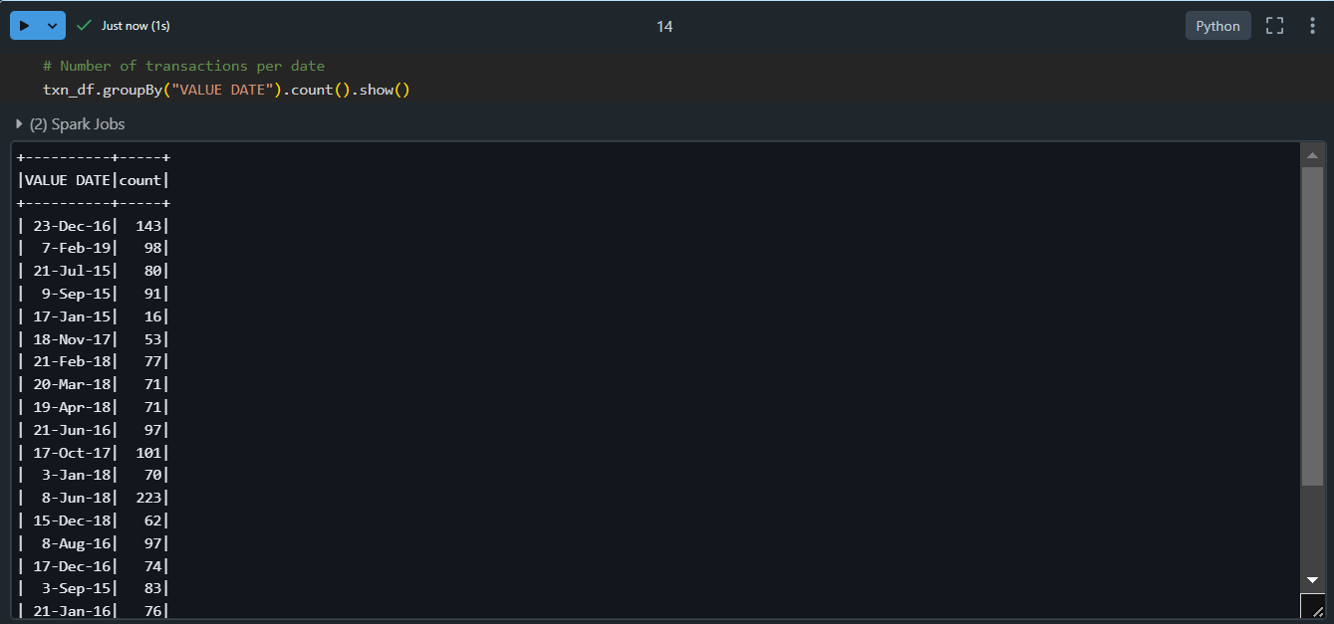

**Explanation:**

* Group by 'Transaction_Date' and count rows in each group.

1. **Customers with withdrawal amount more than 1 lakh:**

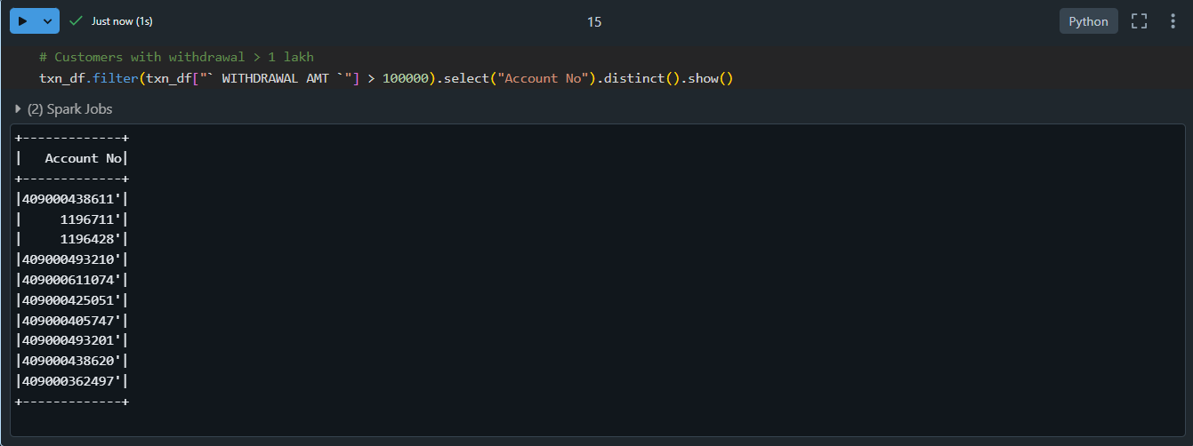

**Explanation:**

* Filter rows where 'Withdrawal_Amount' > 100000 and select unique 'Customer_ID'.